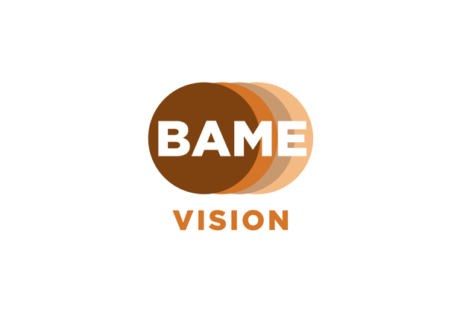

Logo Description: 4 solid circles interlinked, colours left to right, Brown, Tan, Coffee and Beige. The word BAME written in white within and Vision written underneath in tan.

BAME Vision, in collaboration with eye care professionals and people with lived experience, are facilitating a series of informative workshops around this year’s themes of National Eye Health Week. This year, National Eye Health Week runs from the 20th – 26th September 2021

You can find the full schedule and speakers below. To register for any of the sessions, please email info@bamevision.org. All workshops welcome a Q and A session, or email your questions in advance. The link to join via Zoom will be shared with you a few days prior to each workshop. Please do share with your networks and members.

Workshop Schedule:

Workshop 1- Monday 20th September 2021
Time - 7– 8pm

Hosts - Bhavini Makwana, Adam Mapani, Tricia Smikle and Saliha Rashid as a Lived Experience speaker of Leber Congenital Amaurosis

This session will cover:
- Introduction to BAME Vision and what BAME means,
- Sharing our mission and vision,
- Sharing details of the upcoming workshops during the week ahead,
- What is National Eye health week, its aims and this year’s themes,
- Discussing challenges and perception of sight loss within BAME communities,
- How to stay connected to BAME Vision and our projects.

Workshop 2 - Tuesday 21st September 2021
Time - 7 – 8pm

Hosts – Dr Sheena George, Subash Suthar and Nita Patel, a Lived experience speaker living with Diabetes and Management.

Theme: Sight after 60

This session will cover:
- Sharing common eye conditions which are prevalent in BAME communities, in those over the age of 60,
- Sharing resources and services available to support you,
- Ways to manage good eye health and vision,
- Importance of regular eye check-ups and screening,
- Sharing tips on good diet and nutrition.

Workshop 3 - Thursday 23rd September 2021
Time - 7-8pm

Hosts – Jayshree Vasani, Subash Suthar & Bhavini Makwana, a Lived Experience speaker of Retinitis Pigmentosa.

Theme: Live Well and See Well

This session will cover:
- Why good sleep, diet and exercise is important,
- Regular eye check-ups and the importance of having them,
- Who is entitled for free eye tests,
- What can be detected in eye tests?
- Talking about medication and eye drops,
- Sharing impact of screen time and usage,
- Protecting eyes from sun,
- Relax and Breathe- the importance of doing so,
- Clarifying myths around so-called remedies within BAME communities.

Workshop 4 - Friday 24th September 2021
Time - 2-3pm
Hosts - Beverley Drugid, also sharing living with glaucoma, Wayne Chapman and Maxine Plowden, a Lived Experience speaker of Coloboma

Theme: Mental Health and Mindfulness

This session will cover:
- Highlighting the importance of relaxation and taking care of our eyes,
- Sharing the work of an eye care champion,
- Raising awareness of mental health, in particular around having a vision impairment,
- What is mindfulness?
- Practicing mindfulness whilst having sight loss.

Workshop 5 - Sunday 26th September 2021
Time - 1 -2pm
Hosts – Mandy Davidson, Subash Suthar and a Lived Experience speaker of Macular Degeneration Ifzal Khan

Theme: Dry Eyes, Cataracts and myth busting

- What are Dry Eyes?
- Signs and symptoms of Dry Eyes,
- Common causes of Dry Eyes,
- Prevention or remedies of Dry Eyes,
- Cataracts and its effects,
- Living with Cataracts.

We look forward to seeing you at the workshops

