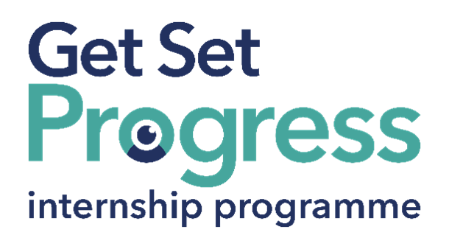

Front Desk Associate Intern

Join us at MertonVision

Thomas Pocklington Trust (TPT) and RNIB are collaborating with organisations from both the sight loss and wider charity sector as well as corporate organisations to create new opportunities for blind and partially sighted people to find employment through the Get Set Progress (GSP) Internship programme. MertonVision is delighted to be offering an internship as part of the Get Set Progress scheme.

About MertonVision
MertonVision was established to grant assistance to all blind and partially sighted persons ordinarily resident of the London Borough of Merton. We visit blind and partially sighted people in their own homes, hospitals or elsewhere with a view to affording them comfort and encouragement and assistance in the solution of domestic and other problems. We provide every other service and assistance necessary for the benefit, health and comfort of blind and partially sighted persons in relation to their visual impairment and any other impairment they may have.’

MertonVision offers both professional and volunteer services to blind and partially sighted adults and children and organises a variety of social and leisure activities. all our activities and center based services
are now available to all people living with hearing loss.

Job description
Role: Front desk Associate Intern
Department: Customer Services
Reporting to: Emma Layfield
Location: Office based The Guardian Centre, 67 Clarendon Road, Colliers Wood, SW19 2DX
Salary: Based on Living Wage Foundation rates
Contract type: Fixed Term, 9 month full-time (35 hrs. per week) contract

Purpose of the role:
To assist in the general running of the organisation as part of the team providing services to visually impaired people and partial deaf/ deaf people in Merton, and to provide a welcoming environment to people who visit or telephone the Guardian Centre

Main responsibilities:
To be the first point of contact for telephone and personal callers, giving them accurate information on services available for people with a Sensory loss, and to refer calls and callers appropriately either in-house or externally.
Telephone/Reception
• Answer telephone in a professional manner, deal with enquiries
where possible, transfer calls, take messages and ensure telephone recording messages working and appropriately.
• Keep informed of the other staff’s whereabouts – i.e. Using
Microsoft Office Calendar and Company Database.
• Maintain a tidy and organised reception area that reflects our
professional standards.

Office
• Keep the electronic diary of activities up to date
• Assist with basic administrative tasks such as data entry, filing,
and scheduling appointments
• Maintain and update records, databases, and filing systems (digital
and paper-based).
• Manage incoming and outgoing mail, deliveries, and courier
services. Open post, record and distribute.
• Support internal teams with ad-hoc tasks to keep the office running
efficiently.
• Assist with organise bookings for hire of hall and rooms and
ensure their specific requirements are met
• Signpost clients to relevant service/dept
• Assist with bi-monthly newsletter.
• Assist Office manager with financial assistance, including booking
in cash and cheques.

Clients
• Assist with bookings for activities, services and transport as
required.
• Ensure correspondence with Clients is recorded using Company
Database.
• And any other tasks as reasonably requested by the Manager

Person specification

Essential criteria
Important information:
- This role has a Genuine Occupational Requirement that the successful applicant be a person who is blind or partially sighted, in line with The Equality Act 2010.
- Interns need to be able to travel to the TPT Hub in London for development events throughout the course of the internship programme (costs covered by TPT).
- Having not previously undertaken the Get Set Progress internship programme.
- Successful applicants must have the Right to Work in the UK for the duration of the Internship. Sponsorship will not be provided.

Essential Person Specification:
• Experience of working closely with people from all sectors of the
community
• Good written and verbal communication skills.
• Proficiency in Microsoft Office (Word, Excel, Outlook)
• Experience of using database input. In-house training on our
database system would be given.
• Ability to demonstrate good organisational skills, such as keeping
a diary, prioritising workload, and recording relevant information
• Knowledge of the impact of visual impairment.

Desirable Person Specification
• Previous experience of working in a reception or customer-facing
role is an advantage.
• A friendly, approachable, and professional manner.
• The ability to multitask and remain calm under pressure.
• Strong organisational skills with the ability to prioritise tasks
effectively.
• A proactive, can-do attitude and willingness to learn.
• Accuracy and attention to detail in all tasks.
• Able to understand and make a commitment to a code of
confidentiality.
• The ability to work well and proactively within a small team.
• Ability to handle difficult situations calmly.

Development and Training
• To be committed to being supervised in accordance with the
agreed supervision procedure.
• To participate in MertonVision staff appraisal scheme and
participate in any training identified through this process.
• To participate in team meetings.

Special requirements

- This post is subject to an enhanced CRB check.

Closing date:
Wednesday 22nd July 2026 at 17:00

How to apply:
To apply, please email your CV with a covering letter regarding your motivations to Kevin Gregory, the CEO, at email kevin.gregory@mertonvision.org.uk

What are the benefits of a Get Set Progress internship for me?
As part of your 9-month internship, you will be part of a large cohort of fellow interns and gain the following:
- Obtain valuable work experience within the charity sector
- Technology support (Including Microsoft Office) and upskilling opportunities
- Online and in-person Training and development opportunities
- Opportunity to present and network with Senior leaders within the Sight Loss Sector
- Opportunities to build relationships with fellow interns
- A personal mentor offering support, advice and guidance throughout your internship
- Help deliver positive changes for people with sight loss


As part of the GSP Internship programme, you will also be enrolled on the TPT Works For Me Employment Programme, where you will gain bespoke employment support, guidance and advice from the TPT Employment Team, some of the skills that you will receive support and guidance around include:
- CV writing
- Job searching
- Cover letter and speculative letter writing
- Application form writing
- Interview techniques



Thomas Pocklington Trust (TPT) is a charity established to provide services for visually impaired people: our mission is to improve the lives of people living with sight loss.

TPT is registered with the Disability Confident Scheme as a Disability Confident employer. Therefore, we believe in treating all employees fairly and we are committed to recruiting equally. TPT’s charitable objective and aim is to support visually impaired individuals back into work. For this reason, we are actively seeking applications from all backgrounds including disabled/visually impaired individuals and people who have lived experience of sight loss. We also guarantee all disabled applicants that reach the minimum appointment criteria an interview. We are happy to accept applications from all suitably qualified people who have the appropriate skills and talent regardless of their age, gender, race, religion, disability, sexual orientation or marital status.

End of Document

